Funded Learning Opportunity
PLANNING LIVE EVENTS

Interested in Event Management?
Want to enhance and grow your skillset?
6 Days Training – fully funded

This course is designed for learners who wish to plan cultural events, and will support the development of their skills in event planning.

Course starts in October and finishes in November – 6 full days in Wolverhampton or Birmingham.

No prior knowledge, understanding, skills or qualifications are required before registration onto this course.

In addition to the course, you also have the opportunity to complete a voluntary work placement in Spain, Italy or Germany of 2 to 8 weeks. This is offered to those who are interested in further enhancing their professional skills.

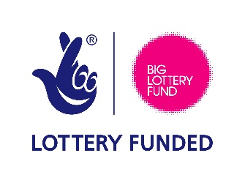
Our work placement programmes are funded by the EU, which means we will pay for your accommodation and travel (including flights), as well as subsistence allowance. To be eligible for the work placement abroad you must hold a valid UK/EU Passport or travel document.

Call 01902 837375 and ask for Ann-Marie Laubscher
or email: ann.laubscher@geckoprogrammes.co.uk

